
Population Genetics of the Short-Beaked Garfish Belone svetovidovi in Turkish Marine Basins Using Mitochondrial Markers
Cemal Turan^{1*}, Petya Pavlova Ivanova² , Servet Ahmet Doğdu^{1,3} , Deniz Ergüden¹ , Violin Stoyanov Raykov² , Maria Yankova² , Deniz Yağlioğlu⁴ , Ayşegül Ergenler¹ , Ivelina Zlateva² , Nina Stoycheva Dzhembekova²
¹Iskenderun Technical University, Faculty of Marine Sciences and Technology, Molecular Ecology and Fisheries Genetics Laboratory, 31200 Iskenderun, Hatay, Türkiye.²Marine Biology and Ecology Department, Institute of Oceanology, Bulgarian Academy of Sciences, First May Street 40, P.O. Box 152, Varna, 9000, Bulgaria. ³Iskenderun Technical University, Maritime Technology Vocational School of Higher Education, Underwater Technologies, 31200 Iskenderun, Hatay, Türkiye. ⁴Department of Biology, Faculty of Arts and Sciences, Duzce University, 81620 Düzce, Türkiye.

Research Article | Abstract  This study investigates the population genetic structure of the short-beaked garfish Belone svetovidovi across the Turkish marine coasts using two mitochondrial markers, cytochrome oxidase I and 12S ribosomal RNA. A total of 280 individuals were sampled from seven sites across the Black Sea, Marmara Sea, and Aegean Sea. Haplotype network analyses showed that COI provided greater resolution, displaying a star-like topology that points to recent population expansion, while 12S rRNA exhibited more conserved patterns, aligning with purifying selection. Tajima’s D values diverged between loci, indicating potential population structuring and demographic processes. Overall, COI captured among-basin differentiation, while 12S rRNA supported deep lineage splits. These findings highlight the complementary nature of mtDNA markers and provide baseline data for future phylogeographic and conservation studies in Belonidae species.  Keywords: Belone svetovidovi, Mitochondrial DNA, COI, 12S rRNA, Population structure
Citation: Turan, C., Ivanova, P. P., Doğdu, S. A., Ergüden, D., Raykov, V. S., Yankova, M., Yağlıoğlu, D., Ergenler, A., Zlateva, I., Dzhembekova, N. S. (2024). Population Genetics of the Short-Beaked Garfish Belone svetovidovi in Turkish Marine Basins Using Mitochondrial Markers. Tethys Env. Sci. 2(3): 138-…...
DOI:
Received: 10 March 2025
Accepted: 18 July 2025
Available Online:
Publication Date: 30 September 2025

Copyright
2025 Turan et al.,
Distributed Under
CC-BY 4.0


Introduction
The Belonidae family, found in all tropical and temperate seas, is recognised by its long bodies and sharp-toothed, long beaks, and comprises 10 genera and 48 valid species worldwide (Fricke et al., 2025). This family is represented in Turkish waters by four species under three genera: Belone belone (Linnaeus, 1760), Belone svetovidovi Collette & Parin, 1970, Tylosurus imperialis (Lacepède, 1803), and Ablennes hians (Valenciennes, 1846) (Karataş et al., 2021; Turan et al., 2023; Irmak and Özden, 2023; Turan et al., 2025).
The short-beaked garfish Belone svetovidovi Collette & Parin, 1986, is a pelagic needlefish species inhabiting tropical and temperate waters. It typically occurs in shallow coastal habitats, predominantly between the surface and 20 m depth (Froese and Pauly, 2025). The distribution of the species extends throughout the Eastern Atlantic, from southern Ireland and the Iberian Peninsula (Spain and Portugal) to Northwest Africa. In addition, it has been documented in the Mediterranean Sea, particularly along the coasts of Türkiye and Israel (Meriç and Altun, 1999; Turan et al., 2023a; Öztürk, 2023; Froese and Pauly, 2025).
Assessing the genetic structure of fish populations provides an important basis for developing sustainable fisheries management and conservation strategies (Palsbøll et al., 2007; Ward, 2000). Molecular markers based on mitochondrial DNA (mtDNA) are widely preferred in such studies due to their haploid nature, absence of recombination, rapid evolutionary dynamics, and maternal inheritance, which together allow for the detection of fine-scale genetic variation within and among populations (Harrison, 1989; Palsbøll et al., 2007; Turan et al., 2015). Among these, the cytochrome c oxidase subunit I (COI) gene is particularly informative, as it constitutes one of the longest protein-coding regions in the mitochondrial genome of metazoans. Owing to its relatively high level of sequence divergence, COI has become a standard marker for both species’ identification and population-level studies, facilitating the exploration of genetic connectivity and demographic history (Galtier et al., 2009; Hurst & Jiggins, 2005; Xu et al., 2014; Ivanova et al., 2021; Turan et al., 2023b; Wei et al., 2023; Yankova et al., 2023). Complementing COI, the mitochondrial 12S rRNA gene, a conserved ribosomal region, offers additional insights by providing resolution for phylogenetic inference and inter-population divergence patterns, thereby strengthening the reliability of genetic analyses (Kocher et al., 1989; Cawthorn et al., 2011). The simultaneous application of COI and 12S rRNA loci in B. svetovidovi enables a robust framework for assessing gene flow, population subdivision, and evolutionary relationships. Such integrative approaches are essential for clarifying the species’ genetic architecture and for guiding effective management actions aimed at mitigating the risks of overfishing and ensuring long-term population sustainability.
This study aims to examine the genetic structure of B. svetovidovi populations along the Turkish coast based on mtDNA COI and 12s rRNA gene datasets.
Material and Methods
Samplings
A total of 280 B. svetovidovi specimens were collected during field studies conducted on the coasts of Muğla (MUG), Izmir (IZM), Çanakkale (CAN), Yalova (YAL), Akçakoca (AKC), Sinop (SIN), and Rize (RIZ) between 2022 and 2024 (Figure 1). The samples were transferred to the laboratory and stored in a -30°C freezer until DNA extraction.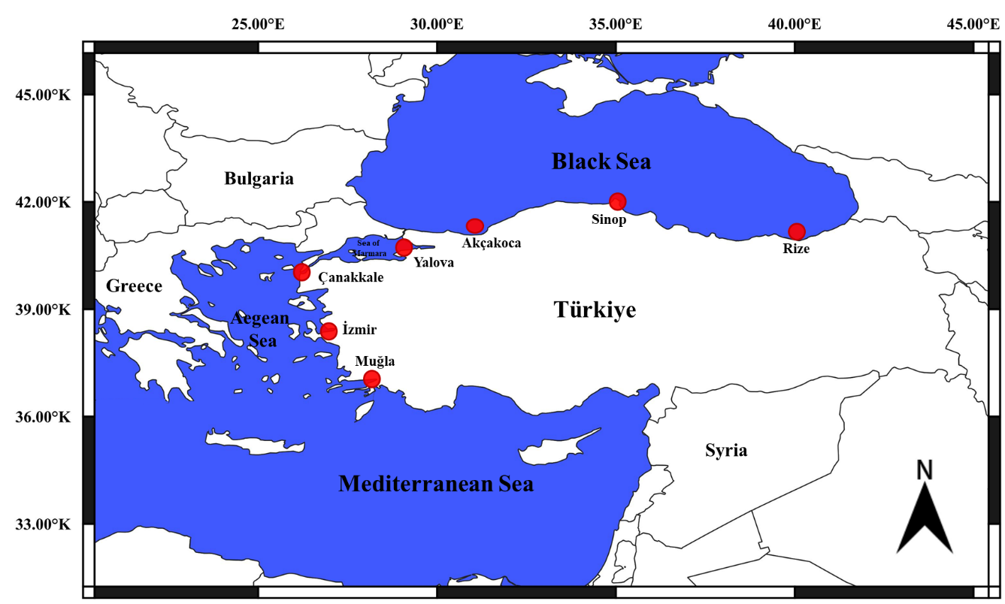
Figure 1. Sampling locations of Belone svetovidovi populations.
Genetic Analysis
Total genomic DNA extraction from muscles was performed using a modified standard phenol:chloroform:isoamyl alcohol protocol (Sambrook et al., 1989). The COI and 12S rRNA genes, previously reported to be effective in garfish species, were amplified using specific primer pairs: COI_F (5’-TCA ACC AAC CAC AAA GAC ATT GGC AC-3’) and COI_R (5’-ACT TCA GGG TGA CCG AAG AAT CAG AA-3’) for COI, and 12s_F (5’-CAA ACT GGG ATT AGA TAC CCC ACT AT-3’) and 12s_R (5’-GAG GGT GAC GGG CGG TGT GT-3’) for 12S rRNA (Lovejoy, 2000; Banford et al., 2004; Imsiridou et al., 2016).
PCR amplification of the COI was initiated with a denaturation step at 95°C for 5 minutes, followed by 35 cycles consisting of: denaturation at 94°C for 30 seconds, annealing at 53°C for 30 seconds, and extension at 72°C for 1.5 minutes. The protocol concluded with a final extension at 72°C for 7 minutes. For the 12S rRNA, amplification began with an initial denaturation at 94°C for 4 minutes, followed by 35 cycles of: denaturation at 94°C for 30 seconds, annealing at 55°C for 30 seconds, and extension at 72°C for 1.5 minutes. A final extension step was performed at 72°C for 7 minutes. The PCR products obtained for both genes were then checked on a 1.5% agarose gel.
DNA sequencing was performed using the chain termination method described by Sanger et al. (1977) with the BigDye Cycle Sequencing Kit v3.1 and an ABI 3130 XL genetic analyser. Sequence analyses were performed on 40 samples from each population for COI and on 10 samples of various sizes from each population for 12s rRNA. The initial alignments of the partial mtDNA sequences were conducted using ClustalW (Thompson et al., 1994), and final adjustments were manually refined with BioEdit (Hall, 1999). Haplotype diversity, nucleotide diversity (Nei, 1987), and the mean number of pairwise differences (Tajima, 1983) were estimated using the Arlequin software (Schneider et al., 2000). Haplotypes were identified with DnaSP 6 (Rozas, 2017), and a minimum spanning tree (MST) of haplotypes was constructed with PopART (Leigh et al., 2015). Phylogenetic relationships were estimated with the MEGAX software (Kumar et al., 2018), using the neighbour-joining (NJ) tree analyses.
Results
COI gene
The sequences of aligned B. svetovidovi populations were analysed using genetic diversity and genetic distance data according to Nei (1978) and Nei and Tajima (1981) to determine the degree of differentiation between populations. The relationship between populations was determined using the NJ tree based on the data obtained. The best-fitting substitution model identified was Tamura-Nei 93 (TN93) (BIC: 10238.017) (Tamura and Nei, 1993).
The length of the sequenced COI region was determined to be 624 bp, which has been submitted to GenBank under accession numbers (Muğla:PX429586-PX429625, Izmir: PX429790-PX429829, Çanakkale: PX429750-PX429789, Yalova: PX431508-PX431547, Akçakoca: PX429630-PX429669, Sinop: PX429710-PX429749, Rize: PX429670-PX429709). The nucleotide composition was determined as follows: thymine (T) 32.3%, cytosine (C) 26.1%, adenine (A) 22.1%, and guanine (G) 19.5%. The analysed 624 bp DNA region includes a 47 bp segment of COI that is evolutionarily conserved and a 577 bp segment showing population-level variation influenced by various factors. Within this variable section, a 572 bp fragment was found to be parsimony-informative across populations.
Genetic diversity was lowest in the Izmir population and highest in the Yalova population (Table 1). The average genetic diversity value between populations was found to be 0.0040.

Table 1. Average genetic diversity and haplotype diversity values of COI within Belone svetovidovi populations.
Population | Genetic diversity/Haplotype Diversity
Muğla | 0.0025/0.3628
Izmir | 0.0005/0.2731
Çanakkale | 0.0074/0.8333
Yalova | 0.0209/0.7577
Akçakoca | 0.0113/0.8513
Sinop | 0.0183/0.7962
Rize | 0.0056/0.6269

A total of 44 haplotypes were identified in COI between seven populations of B. svetovidovi. The average haplotype diversity among populations was calculated as 0.8560. Specifically, the Muğla population exhibited 11 haplotypes, Izmir 3 haplotypes, Çanakkale 10 haplotypes, Yalova 8 haplotypes, Akçakoca 8 haplotypes, Sinop 8 haplotypes, and Rize 8 haplotypes (Table 2).
Table 2. Frequencies and distribution of COI haplotypes in B. svetovidovi populations.
Haplotype | Muğla | Izmir | Çanakkale | Yalova | Akçakoca | Sinop | Rize | Total
Hap_1 | - | - | - | - | 5 | - | - | 5
Hap_2 | - | - | - | - | 11 | - | - | 11
Hap_3 | - | - | - | - | 3 | - | - | 3
Hap_4 | - | - | - | - | 3 | - | - | 3
Hap_5 | - | - | - | - | 3 | - | - | 3
Hap_6 | - | - | - | - | 3 | - | - | 3
Hap_7 | - | - | - | - | 9 | - | - | 9
Hap_8 | - | - | - | - | 3 | - | - | 3
Hap_9 | 26 | 34 | 21 | 19 | - | - | - | 100
Hap_10 | 1 | 3 | 1 | - | - | - | - | 5
Hap_11 | 2 | 3 | - | - | - | - | - | 5
Hap_12 | - | - | - | - | - | - | 1 | 1
Hap_13 | - | - | - | - | - | - | 4 | 4
Hap_14 | - | - | - | - | - | - | 3 | 3
Hap_15 | - | - | - | - | - | - | 24 | 24
Hap_16 | - | - | - | - | - | - | 3 | 3
Hap_17 | - | - | - | - | - | - | 3 | 3
Hap_18 | - | - | - | - | - | - | 1 | 1
Hap_19 | - | - | - | - | - | - | 1 | 1
Hap_20 | - | - | - | - | - | 12 | - | 12
Hap_21 | - | - | - | - | - | 3 | - | 3
Hap_22 | - | - | - | - | - | 3 | - | 3
Hap_23 | - | - | - | - | - | 3 | - | 3
Hap_24 | - | - | - | - | - | 13 | - | 13
Hap_25 | - | - | - | - | - | 4 | - | 4
Hap_26 | - | - | - | - | - | 1 | - | 1
Hap_27 | - | - | - | - | - | 1 | - | 1
Hap_28 | - | - | - | 2 | - | - | - | 2
Hap_29 | - | - | - | 2 | - | - | - | 2
Hap_30 | - | - | - | 2 | - | - | - | 2
Hap_31 | - | - | 3 | 3 | - | - | - | 6
Hap_32 | - | - | 1 | 5 | - | - | - | 6
Hap_33 | - | - | 1 | 4 | - | - | - | 5
Hap_34 | 4 | - | 1 | - | - | - | - | 5
Hap_35 | 1 | - | 2 | 3 | - | - | - | 6
Hap_36 | - | - | 2 | - | - | - | - | 2
Hap_37 | - | - | 1 | - | - | - | - | 1
Hap_38 | - | - | 7 | - | - | - | - | 7
Hap_39 | 1 | - | - | - | - | - | - | 1
Hap_40 | 1 | - | - | - | - | - | - | 1
Hap_41 | 1 | - | - | - | - | - | - | 1
Hap_42 | 1 | - | - | - | - | - | - | 1
Hap_43 | 1 | - | - | - | - | - | - | 1
Hap_44 | 1 | - | - | - | - | - | - | 1
Total | 40 | 40 | 40 | 40 | 40 | 40 | 40 | 280
The haplotype diversity values obtained for B. svetovidovi populations were presented in Table 1. The highest haplotype diversity value within the populations was observed in the Akçakoca population (0.8513), while the lowest was observed in the Izmir population (0.2731). The average haplotype diversity obtained from the 280 sequences analysed was found to be 0.8560. The minimum spanning tree showing the haplotype relationship between populations is shown in Figure 2.
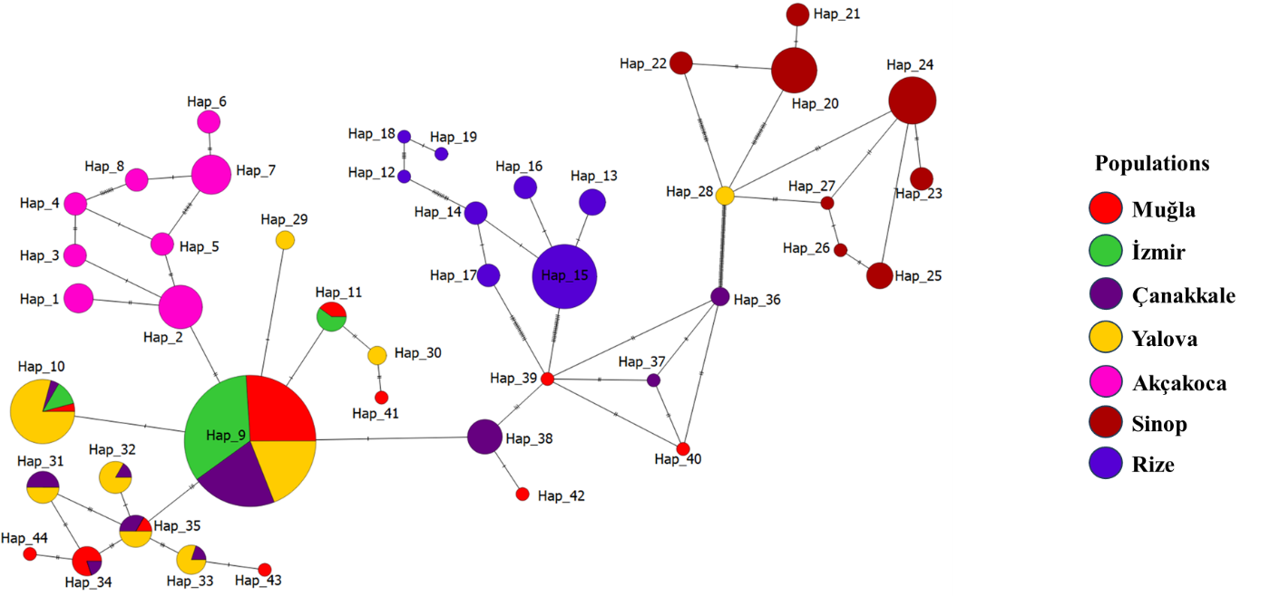
Figure 2. Minimum spanning tree showing evolutionary mutation relationships between haplotypes in the COI gene for B. svetovidovi populations.
The lowest genetic distance was found between Muğla and Izmir (0.0016) populations, while the highest distance was between the Izmir and Sinop (0.2125) populations (Table 3).
Table 3. Average genetic distance between B. svetovidovi populations for COI.
Population | Akçakoca | Izmir | Rize | Sinop | Yalova | Çanakkale
Izmir | 0.1828
Rize | 0.1619 | 0.1121
Sinop | 0.0096 | 0.2125 | 0.1610
Yalova | 0.0240 | 0.0118 | 0.1826 | 0.1686
Çanakkale | 0.1168 | 0.0046 | 0.1831 | 0.1852 | 0.0125
Muğla | 0.1838 | 0.0016 | 0.1829 | 0.1836 | 0.0162 | 0.0052
The NJ tree revealed a distinct clustering of populations. Muğla and Izmir populations were located on the same branch, demonstrating a close genetic relationship. The Çanakkale population was the closest group to this pair. The Yalova population was located on a separate branch, while the Akçakoca and Sinop populations were grouped, demonstrating genetic similarity. The Rize population was located at the far end of the tree, exhibiting a more distant genetic position from the other populations (Figure 3). NJ analysis of COI showed that, in general, the genetic distances of the populations paralleled their geographical distributions, but the Yalova population in Marmara was an exception, being geographically closer to the Aegean group rather than the Black Sea group.
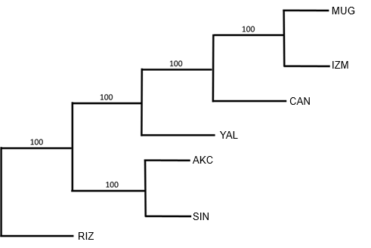
Figure 3. NJ tree showing the genetic relationship of B. svetovidovi populations based on the COI gene.
To test the stability of populations, Tajima’s (1989) neutrality test was applied (Table 4). This test distinguishes between DNA sequences that have evolved naturally and those that have evolved through non-natural processes. The result of the Tajima neutrality test was a (D) value of 1.343342.
Table 4. Tajima neutrality test for the COI gene in B. svetovidovi populations.
m | S | Ps | Θ | π | D
280 | 127 | 0. 228007 | 0.036715 | 0.052901 | 1.343342
m, number of sequences; S, total number of polymorphic regions; Ps, polymorphic region ratio; Θ, group mutation rate; π, nucleotide differences; D, Tajima neutrality value.
12S rRNA Gene
The degree of differentiation between populations of B. svetovidovi was determined using genetic diversity and genetic distance data aligned with 12S rRNA gene sequences (Nei, 1978; Nei and Tajima, 1981). The relationship between populations was determined using the NJ tree based on the data obtained. Jukes-Cantor (JC) model (Jukes and Cantor, 1969) was selected as the optimal substitution model based on its BIC score (2702.306).
The length of the sequenced 12S rRNA region was determined to be 425 bp, which has been submitted to GenBank under accession numbers PV124771.1-PV124775.1. The nucleotide composition of the 12S rRNA gene was determined as follows: thymine (T) 21.2%, cytosine (C) 26.8%, adenine (A) 29.9%, and guanine (G) 22.0%. Of the total sequence, 419 bp were identified as evolutionarily conserved regions, while 6 bp exhibited population-specific variability due to diverse factors. A 4 bp fragment within this variable region was found to be phylogenetically informative, serving as a parsimony-informative site among populations.
Genetic diversity was lowest in the Akçakoca population, whereas the highest diversity was detected in the Çanakkale population (Table 5). The average genetic diversity value between populations was found to be 0.0008.
Table 5. Average genetic diversity and haplotype diversity values of 12s rRNA within B. svetovidovi populations.
Population | Genetic diversity/Haplotype Diversity
Muğla | 0.0008/0.2000
İzmir | 0.0017/0.4500
Çanakkale | 0.0019/0.4500
Yalova | 0.0005/0.3000
Akçakoca | 0.0001/0.0001
Sinop | 0.0005/0.2000
Rize | 0.0005/0.2000
A total of seven different haplotypes were detected in the 12S rRNA dataset analysed in seven populations of B. svetovidovi. The mean haplotype diversity was calculated as 0.5557. Detailed haplotype frequency distributions for the 12S rRNA were presented in Table 6.
Table 6. Frequencies and distribution of 12S rRNA haplotypes in B. svetovidovi populations.
Haplotype | Muğla | Izmir | Çanakkale | Yalova | Akçakoca | Sinop | Rize | Total
Hap_1 | 2 | 2 | 3 | 8 | 10 | 9 | 9 | 43
Hap_2 | - | - | - | 1 | - | 1 | 1 | 3
Hap_3 | - | - | - | 1 | - | - | - | 1
Hap_4 | 8 | 6 | 5 | - | - | - | - | 19
Hap_5 | - | - | 1 | - | - | - | - | 1
Hap_6 | - | - | 1 | - | - | - | - | 1
Hap_7 | - | 2 | - | - | - | - | - | 2
Total | 10 | 10 | 10 | 10 | 10 | 10 | 10 | 70
Haplotype diversity values for B. svetovidovi populations were summarised in Table 5. Among the sampled populations, the highest haplotype diversity was determined in Çanakkale (0.4500), whereas the lowest was observed in Akçakoca (0.0001). The mean haplotype diversity was calculated as 0.5557 for 70 sequences analysed. The haplotype relationships among populations were illustrated in the minimum spanning tree presented in Figure 4.
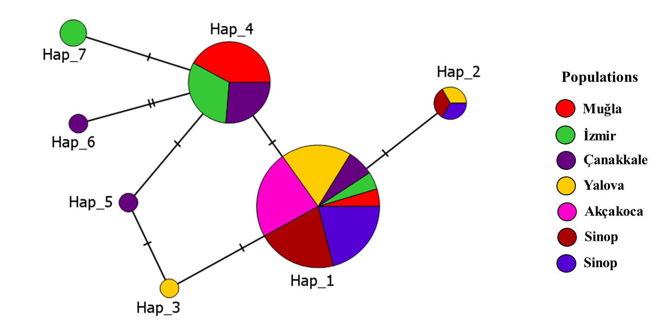
Figure 4. Minimum spanning tree showing evolutionary mutation relationships between haplotypes in the 12S rRNA gene for B. svetovidovi populations.
The lowest genetic distance was found between Muğla-Akçakoca and Muğla-Izmir (0.0001) populations, while the highest distance was between Çanakkale-Rize, Çanakkale-Sinop, and Çanakkale-Yalova (0.0030) populations (Table 7).
Table 7. Average genetic distance between B. svetovidovi populations for 12S rRNA.
Population | Akçakoca | Rize | Sinop | Yalova | Çanakkale | Izmir
Rize | 0.0002
Sinop | 0.0002 | 0.0004
Yalova | 0.0002 | 0.0004 | 0.0004
Çanakkale | 0.0028 | 0.0030 | 0.0030 | 0.0030
İzmir | 0.0023 | 0.0025 | 0.0025 | 0.0025 | 0.0017
Muğla | 0.0001 | 0.0021 | 0.0021 | 0.0021 | 0.0013 | 0.0001
The NJ tree showed clear clustering of populations. Muğla and Izmir populations shared the same branch, indicating a close genetic relationship. The Yalova population was the nearest branch to this group. The Akçakoca population was on a separate branch, while the Rize and Sinop populations were grouped, reflecting genetic similarity. The Çanakkale population appeared at the far end of the tree, showing a more distant genetic position from the other populations. (Figure 5). NJ analysis of 12S rRNA also revealed that the genetic distances of the populations were generally consistent with their geographical distributions. However, this agreement was not fully consistent, as the Çanakkale population was located distant from the other Aegean populations and Yalova, a Marmara population, was closer to the Aegean group than to the Black Sea.
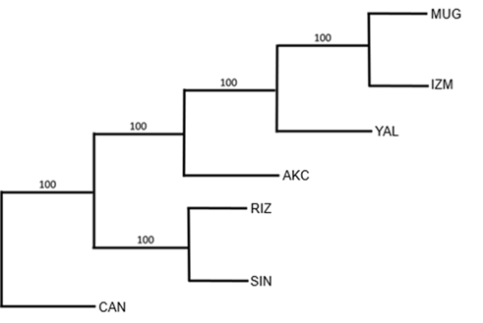
Figure 5. NJ tree showing the genetic relationship of B. svetovidovi populations based on the 12S rRNA gene.
To test the stability of populations, Tajima’s (1989) neutrality test was applied (Table 8). This test distinguishes between a DNA sequence that developed naturally and a DNA sequence that developed through unnatural processes. The result of the Tajima neutrality test was found to be -1.060866.
Table 8. Tajima neutrality test for the 12S rRNA gene in B. svetovidovi populations.
m | S | Ps | Θ | π | D
70 | 6 | 0. 014118 | 0.002930 | 0.001628 | -1.060866
m, number of sequences; S, total number of polymorphic regions; Ps, polymorphic region ratio; Θ, group mutation rate; π, nucleotide differences; D, Tajima neutrality value.
Discussion
In this study, B. svetovidovi populations collected from Muğla, Izmir and Çanakkale coasts of the Aegean Sea; Yalova coast of the Marmara Sea; and Akçakoca, Sinop and Rize coasts of the Black Sea were analysed using both COI and 12S rRNA genes.
COI dataset observed extensive haplotype richness (44 haplotypes across 280 individuals) with high mean haplotype diversity (Hd = 0.8560) but low genetic diversity (π = 0.0040) (Table 1–2), while 12S rRNA revealed low haplotype number (n = 7) and very low genetic diversity (π = 0.0016) (Table 5-6). The combination of high haplotype diversity and low nucleotide diversity has been widely observed in marine fish and can generally be interpreted as a sign of large effective sizes and recent demographic growth or post-bottleneck expansion (Rogers and Harpending, 1992; Grant and Bowen, 1998; Xu et al., 2024). The faster evolutionary rate and more extensive genetic pool of COI explain its higher resolution compared to the more conserved region of 12S rRNA.
Neighbour-joining (NJ) analyses revealed that genetic distances between populations for both COI and 12S rRNA genes generally coincided with their geographic distributions. The Black Sea populations (Akçakoca, Sinop, Rize) were clearly separated from the populations of the Aegean and Marmara Seas. However, for both genes, the Yalova population stands out as a notable exception; despite being located in the Marmara Sea, it is genetically closer to the Aegean group than to the Black Sea group. Additionally, in the tree 12S rRNA dataset, the Çanakkale population did not fully conform to geographical expectations, being genetically more distant from other Aegean Sea populations (Muğla and Izmir) (Figures 3 and 5). Pairwise COI distances were determined as minimum (0.0016) between Muğla and Izmir, and maximum (0.2125) between Izmir and Sinop; 12S rRNA distances were found to be minimum (0.0001) between Muğla and Akçakoca, and Muğla and Izmir, while the maximum (0.0030) was observed among the populations of Çanakkale, Rize, Sinop, and Yalova. These observations, with some exceptions, support a geographical separation (Table 3). The findings are consistent with the Turkish Straits System (TSS) acting as a semi-permeable filter. The hydrodynamic regime of the Bosphorus–Marmara–Çanakkale, including two-layer exchange and internal hydraulic controls at sills and constrictions, can restrict the dispersal of pelagic taxa and promote basin-level structure (Oğuz, 2005; Jarosz et al., 2013; Sözer and Özsoy, 2017; Sannino et al., 2017). Evidence from regional population genetic studies likewise indicates differentiation patterns consistent with limited connectivity across the TSS in some marine organisms (Çetin et al., 2022).
Neutrality test results differ between genes: Tajima’s D was positive for COI (D ≈ +1.34), whereas 12S rRNA shows a negative value (D ≈ –1.06) (Tables 4 and 8). In marine fish, positive Tajima’s D values are commonly associated with population subdivision or admixture, often driven by environmental heterogeneity and limited gene flow across biogeographic barriers, rather than balancing selection. This pattern reflects the Wahlund effect, where mixing of genetically distinct subpopulations elevates intermediate-frequency variants (Brown, 1986; Wilson et al., 2004). In this study, basin-specific haplotype frequencies and the genetic discontinuity across sites are more consistent with structure-driven patterns than with balancing selection acting on the COI locus. In contrast, the mildly negative Tajima’s D for 12S rRNA aligns with expectations for functionally conserved mitochondrial loci, which are typically under purifying selection, and may also reflect a recent population expansion, as observed in other marine fishes (Liu et al., 2012; Joseph et al., 2019). Although Tajima’s D should be interpreted with caution due to its sensitivity to demography and model assumptions, the locus-specific patterns observed here are congruent with geography-driven population structure in marine environments, where gene flow may be restricted by ecological or oceanographic barriers (González et al., 2008).
Within-population genetic diversity varies notably across sampling sites. Izmir population displays the lowest mitochondrial COI diversity (π = 0.0005; Hd = 0.2731), a pattern often interpreted as indicative of a recent founder event, population bottleneck, or strong sweepstakes recruitment, all of which are known to reduce genetic variability in marine fish populations (Grant and Bowen, 1998). In contrast, higher diversity levels observed in Yalova and Akçakoca suggest longer-term demographic stability or admixture from multiple source populations. The COI-based minimum spanning tree shows a topology closer to star-like radiation, consistent with recent population expansion following historical contractions, a common signature among pelagic and semi-pelagic marine fishes influenced by Pleistocene–Holocene oceanographic regime shifts (Lecomte et al., 2004). Similar patterns have been reported in sardines and anchovies, where shallow genealogies and high-frequency haplotypes reflect expansions likely driven by climatic and oceanographic variability (Grant & Bowen, 1998; Mills et al., 2008).
In marine fish population genetics, mitochondrial markers such as COI and 12S rRNA are frequently employed due to their high amplification success and maternal inheritance. Among Belonidae and other teleosts, COI has consistently shown high resolution for identifying closely related taxa and detecting fine-scale population structure, especially in dynamic coastal systems (Mgeleka et al., 2023; Turan et al., 2025). Despite its lower within-species variability, 12S rRNA complements COI by providing robust clade validation, and its universality across taxa makes it highly suitable for comparative studies (Fontes et al., 2024).
This study clearly demonstrates this complementarity. COI effectively resolves population structure across basins and reveals distinct haplogroups, while 12S rRNA confirms major lineage distinctions but tends to mask more subtle within-basin variation due to its conserved structure. Similar patterns have been observed in other marine fish taxa, highlighting the importance of multi-locus approaches for robust inference of population differentiation and historical demography (Ye et al., 2018; Tárula-Marín et al., 2024).
In conclusion, this study demonstrates that Belone svetovidovi populations in the Aegean, Marmara, and Black Sea exhibit clear genetic structuring shaped by the Turkish Straits System. COI revealed high haplotype richness and basin-level differentiation, while 12S provided conservative support for major lineages. The pattern of high haplotype diversity with low nucleotide diversity indicates historical demographic expansion, whereas locus-specific neutrality results point to both population subdivision and purifying selection. These findings emphasise the importance of multilocus approaches and suggest that Aegean–Marmara and Black Sea groups should be considered provisional management units to guide conservation and sustainable fisheries practices.
References
Banford, H. M., Bermingham, E., & Collette, B. B. (2004). Molecular phylogenetics and biogeography of transisthmian and amphi-Atlantic needlefishes (Belonidae: Strongylura and Tylosurus): perspectives on New World marine speciation. Molecular Phylogenetics and Evolution, 31(3), 833-851.
Brown, K. L. (1986). Population demographic and genetic structure of plains killifish from the Kansas and Arkansas river basins in Kansas. Transactions of the American Fisheries Society, 115(4), 568-576.
Cawthorn, D. M., Steinman, H. A., & Witthuhn, R. C. (2012). Evaluation of the 16S and 12S rRNA genes as universal markers for the identification of commercial fish species in South Africa. Gene, 491(1), 40-48.
Çetin, C., Furman, A., Kalkan, E., & Bilgin, R. (2022). Mitonuclear genetic patterns of divergence in the marbled crab, Pachygrapsus marmoratus (Fabricius, 1787) along the Turkish seas. Plos one, 17(4), e0266506.
Fontes, J. T., Katoh, K., Pires, R., Soares, P., & Costa, F. O. (2024). Benchmarking the discrimination power of commonly used markers and amplicons in marine fish (e) DNA (meta) barcoding. ARPHA Preprints, 5, e128777.
Fricke R, Eschmeyer WN, Van der Laan R (eds) (2025). Eschmeyer's Catalog of Fishes: Genera, Species, References. Electronic version accessed 12 Feb 2025.
Froese R, Pauly D. FishBase. (2025). Available from: http://www.fishbase.org, Version (06 ⁄ 2025).
Galtier, N., Nabholz, B., Glémin, S., & Hurst, G. D. D. (2009). Mitochondrial DNA as a marker of molecular diversity: a reappraisal. Molecular Ecology, 18(22), 4541-4550.
Gonzalez, E. G., Beerli, P., & Zardoya, R. (2008). Genetic structuring and migration patterns of Atlantic bigeye tuna, Thunnus obesus (Lowe, 1839). BMC Evolutionary Biology, 8(1), 252.
Grant, W. A. S., & Bowen, B. W. (1998). Shallow population histories in deep evolutionary lineages of marine fishes: insights from sardines and anchovies and lessons for conservation. Journal of Heredity, 89(5), 415-426.
Hall, T., Biosciences, I., & Carlsbad, C. J. G. B. B. (2011). BioEdit: an important software for molecular biology. GERF Bull Biosci, 2(1), 60-61.
Harrison, R. G. (1989). Animal mitochondrial DNA as a genetic marker in population and evolutionary biology. Trends in Ecology & Evolution, 4(1), 6-11.
Hurst, G. D., & Jiggins, F. M. (2005). Problems with mitochondrial DNA as a marker in population, phylogeographic and phylogenetic studies: the effects of inherited symbionts. Proceedings of the Royal Society B: Biological Sciences, 272(1572), 1525-1534.
Imsiridou, A., Minos, G., Kokokiris, L., Alexandrou, M., Kyriakidou, M., & Karidas, T. (2016). Genetic and phenotypic identification of Tylosurus acus imperialis in Thermaikos Gulf, North Aegean Sea. Cahiers de Biologie Marine, 57, 9-15.
Irmak, E., & Özden, U. (2023). Expansion of the flat needlefish Ablennes hians (Valenciennes, 1846) distribution in the eastern Mediterranean. Acta Adriatica, 64(1), 91-92. doi:10.32582/aa.64.1.6
Ivanova, P., Dzhembekova, N., Atanassov, I., Rusanov, K., Raykov, V., Zlateva, I., ... & Nikolov, G. (2021). Genetic diversity and morphological characterisation of three turbot (Scophthalmus maximus L., 1758) populations along the Bulgarian Black Sea coast. Nature Conservation, 43, 123-146.
Jarosz, E., Teague, W. J., Book, J. W., & Beşiktepe, Ş. T. (2013). Observed volume fluxes and mixing in the Dardanelles Strait. Journal of Geophysical Research: Oceans, 118(10), 5007-5021.
Joseph, J., Sreedharan, S., Anoop, V. S., George, S., & Antony, M. M. (2019). A preliminary investigation on the population genetic structure of Etroplus canarensis day, 1877 of the Western Ghats, India. Asian Fish Sci, 32, 190-195.
Jukes, T. H., & Cantor, C. R. (1969). Evolution of protein molecules. Mammalian Protein Metabolism, 3(21), 132.
Karataş, A., Filiz, H., Erciyas-Yavuz, K., Özeren, S. C., & Tok, C. V. (2021). The vertebrate biodiversity of Turkey. In Biodiversity, Conservation and Sustainability in Asia: Volume 1: Prospects and Challenges in West Asia and Caucasus (pp. 175-274). Cham: Springer International Publishing.
Kocher, T. D., Thomas, W. K., Meyer, A., Edwards, S. V., Pääbo, S., Villablanca, F. X., & Wilson, A. C. (1989). Dynamics of mitochondrial DNA evolution in animals: amplification and sequencing with conserved primers. Proceedings of the National Academy of Sciences, 86(16), 6196-6200.
Kumar, S., Stecher, G., Li, M., Knyaz, C., Tamura, K. (2018). MEGA X: Molecular evolutionary genetics analysis across computing platforms. Molecular Biology and Evolution, 35(6), 1547-1549.
Lecomte, F., Grant, W. S., Dodson, J. J., Rodríguez‐Sánchez, R., & Bowen, B. W. (2004). Living with uncertainty: genetic imprints of climate shifts in East Pacific anchovy (Engraulis mordax) and sardine (Sardinops sagax). Molecular Ecology, 13(8), 2169-2182.
Leigh, J. W., Bryant, D., & Nakagawa, S. (2015). POPART: full-feature software for haplotype network construction. Methods in Ecology & Evolution, 6(9).
Liu, G., Zhou, J., & Zhou, D. (2012). Mitochondrial DNA reveals low population differentiation in elongate loach, Leptobotia elongata (Bleeker): implications for conservation. Environmental Biology of Fishes, 93(3), 393-402.
Lovejoy, N. R., & Collette, B. B. (2001). Phylogenetic relationships of New World needlefishes (Teleostei: Belonidae) and the biogeography of transitions between marine and freshwater habitats. Ichthyology & Herpetology, 2001(2), 324-338.
Meriç, N., Altun, Ö. (1999). The garfish, Belone svetovidovi Collette and Parin, 1970, New to the Aegean Sea. Israel Journal of Zoology, 45: 423-426.
Mgeleka, S. S., Silas, M. O., Mtonga, C., Rumisha, C., Viinamäki, E., Polte, P., ... & Gullström, M. (2023). Population genetics of the hound needlefish Tylosurus crocodilus (Belonidae) indicate high connectivity in Tanzanian coastal waters. Marine Biology Research, 19(4-5), 261-270.
Mills, C. E., Hadwen, W. L., & Hughes, J. M. (2008). Looking through glassfish: marine genetic structure in an estuarine species. Marine and Freshwater Research, 59(7), 627-637.
Nei, M. (1987). Molecular evolutionary genetics. Columbia University Press.
Nei, M., & Tajima, F. (1981). DNA polymorphism detectable by restriction endonucleases. Genetics, 97(1), 145-163.
Oguz, T. (2005). Hydraulic adjustments of the Bosphorus exchange flow. Geophysical Research Letters, 32(6).
Öztürk, D. S. (2023). Molecular and phenotypic characteristics of short-beaked garfish Belone svetovidovi Collette and Parin, 1970 in a new location, the Sea of Marmara. Marine Science and Technology Bulletin, 12(2), 156-161.
Palsbøll, P. J., Berube, M., & Allendorf, F. W. (2007). Identification of management units using population genetic data. Trends in Ecology & Evolution, 22(1), 11-16.
Rogers, A. R., & Harpending, H. (1992). Population growth makes waves in the distribution of pairwise genetic differences. Molecular Biology and Evolution, 9(3), 552-569.
Rozas, J., Ferrer-Mata, A., Sánchez-DelBarrio, J. C., Guirao-Rico, S., Librado, P., Ramos-Onsins, S. E., & Sánchez-Gracia, A. (2017). DnaSP 6: DNA sequence polymorphism analysis of large data sets. Molecular Biology and Evolution, 34(12), 3299-3302.
Sambrook, J., Fritsch, E. F., & Maniatis, T. (1989). Molecular cloning: a laboratory manual (No. Ed. 2, pp. xxxviii+-1546).
Schneider, S. (2000). Arlequin ver 2.000: a soft ware for population genetics data analysis. Genetics and Biometry Laboratory, Dept of Anthropology and Ecology.
Sözer, A., & Özsoy, E. (2019). Hydrodynamic Model Analysis of an Idealized Bosphorus Case with respect to Switching Steady-State Solutions. Ordu Üniversitesi Bilim ve Teknoloji Dergisi, 9(1), 1-17.
Tajima, F. (1983). Evolutionary relationship of DNA sequences in finite populations. Genetics, 105(2), 437-460.
Tajima, F. (1989). Statistical method for testing the neutral mutation hypothesis by DNA polymorphism. Genetics, 123(3), 585-595.
Tamura, K., Nei, M. (1993). Estimation of the number of nucleotide substitutions in the control region of mitochondrial DNA in humans and chimpanzees. Molecular Biology and Evolution, 10(3), 512-526.
Tárula-Marín, A., Díaz-Cárdenas, B., Castro-Félix, L. P., López-Uriarte, E., Santerre, A., & Aréchiga-Palomera, M. A. (2024). Genetic diversity, population structure and demographic history of the rock oyster Striostrea prismatica (Gray, 1825) within two Eastern Pacific biogeographic realms. Marine and Freshwater Research, 75(9).
Thompson, J. D., Higgins, D. G., & Gibson, T. J. (1994). CLUSTAL W: improving the sensitivity of progressive multiple sequence alignment through sequence weighting, position-specific gap penalties and weight matrix choice. Nucleic Acids Research, 22(22), 4673-4680.
Turan, C., Gurlek, M., Erguden, D., Yaglioglu, D., Uyan, A., Reyhaniye, A. N., ... & Soldo, A. (2015). Population genetic analysis of Atlantic bonito Sarda sarda (Bloch, 1793) using sequence analysis of mtDNA D-loop region. Fresenius Environmental Bulletin, 24(10), 3148-3154.
Turan, C., Ivanova, P. P., Doğdu, S. A., Ergüden, D., Raykov, V. S., Yankova, M., ... & Ergenler, A. (2025). Systematic identification of needlefish (Belonidae) species using molecular genetic and morphological markers in the Mediterranean and Black Seas. PloS One, 20(2), e0315401.
Turan, C., Uyan, A., Atalay, M. A., Dogdu, S. A., Ayas, D., Erguden, D., ... & Gurlek, M. (2023b). Genetic differentiation of round sardinella Sardinella aurita (Clupeidae) populations from the Northeastern Mediterranean. Journal of Ichthyology, 63(5), 962-968.
Turan, C., Yağlıoğlu, D., Doğdu, S. A., Ergüden, D., Ivanova, P. P., & Raykov, V. S. (2023a). Existence of Belone svetovidovi Collette & Parin, 1970 (Family: Belonidae) in the Marmara Sea and Black Sea Coasts of Türkiye. Natural and Engineering Sciences, 8(2), 72-81.
Turan, C., Yağlıoğlu, D., Doğdu, S. A., Ergüden, D., Ivanova, P. P., & Raykov, V. S. (2023). Existence of Belone svetovidovi Collette & Parin, 1970 (Family: Belonidae) in the Marmara Sea and Black Sea coasts of Türkiye. Natural and Engineering Sciences, 8(2), 72-81.
Ward, R. D. (2000). Genetics in fisheries management. Hydrobiologia, 420(1), 191-201.
Wei, H., Geng, L., Shang, X., Li, L., Ma, B., Zhang, Y., ... & Xu, W. (2023). Comparison genetic diversity and population structure of four Pseudaspius leptocephalus populations in Heilongjiang River Basin based on mitochondrial COI gene. Frontiers in Marine Science, 10, 1158845.
Wilson, A. J., Gislason, D., Skúlason, S., Snorrason, S. S., Adams, C. E., Alexander, G., ... & Ferguson, M. M. (2004). Population genetic structure of Arctic charr, Salvelinus alpinus from northwest Europe on large and small spatial scales. Molecular Ecology, 13(5), 1129-1142.
Xu, H., Huang, L., Chen, T., Wang, C., Wu, Z., Cheng, Y., ... & Zhang, X. (2024). Phylogeography and population structure of Lagocephalus spadiceus (Richardson, 1845)(Tetraodontiformes, Tetraodontidae) in the South China Sea. Ecology and Evolution, 14(4), e11320.
Xu, H., Zhang, Y., Xu, D., Lou, B., Guo, Y., Sun, X., & Guo, B. (2014). Genetic population structure of miiuy croaker (Miichthys miiuy) in the Yellow and East China Seas base on mitochondrial COI sequences. Biochemical Systematics and Ecology, 54, 240-246.
Yankova, M., Raykov, V., Ivanova, P., Dzhembekova, N., Turan, C., & Raev, Y. (2023). Morphological and genetic characteristics of garfish Belone belone (L., 1760)(Belonidae, Teleostei) population from the southern Bulgarian Black Sea coast. Nature Conservation, 54, 1-12.
Ye, Y., Fu, Z., Tian, Y., Li, J., Guo, B., Lv, Z., & Wu, C. (2018). Pelagic larval dispersal habits influence the population genetic structure of clam Gomphina aequilatera in China. Genes & Genomics, 40(11), 1213-1223.

